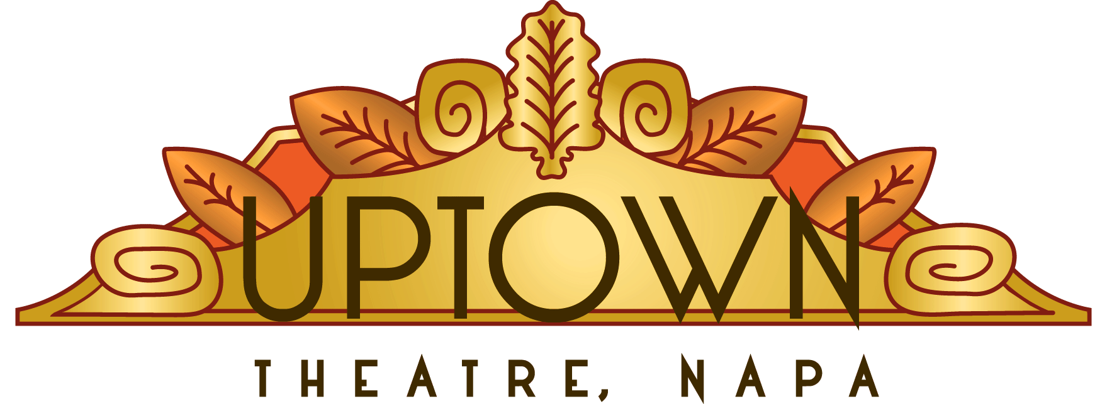
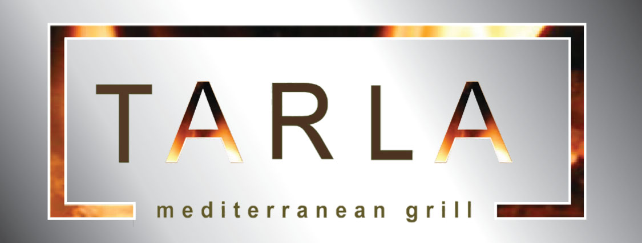

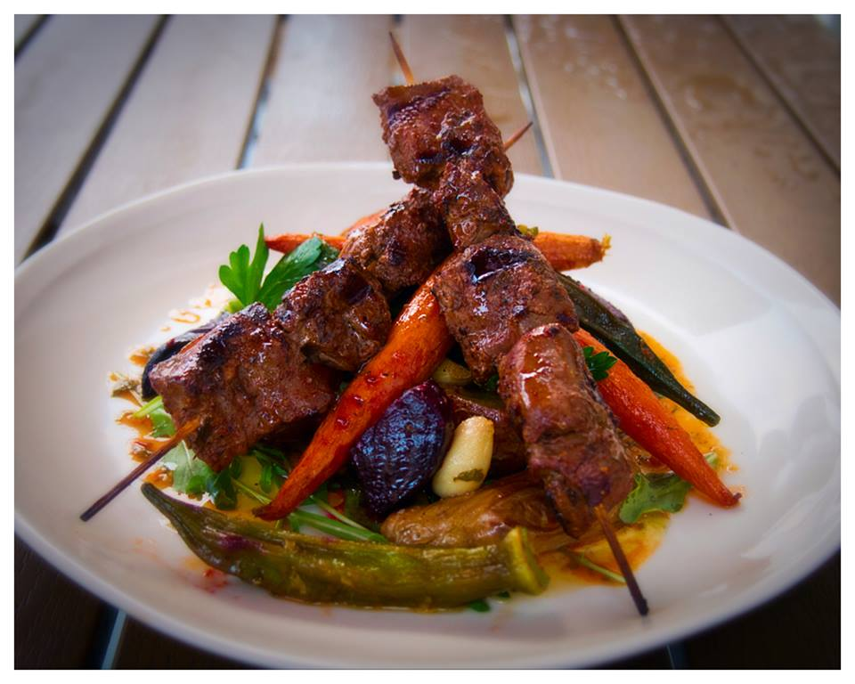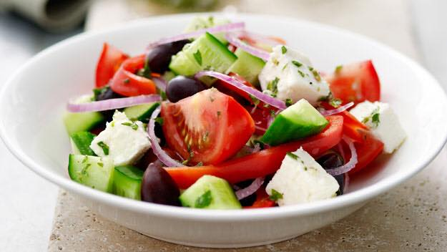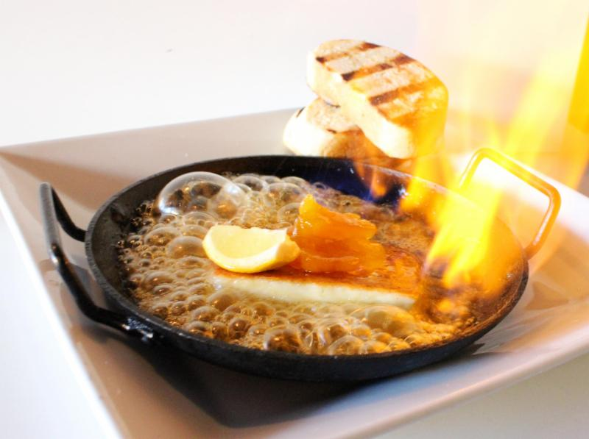

DINING + UPTOWN SHOW PACKAGE
Three Course Dinner and Show Tickets for $104
Three Course Dinner with Wine Pairing and Show Tickets $129
Here’s your opportunity to enjoy a night on the town in beautiful downtown Napa with two tickets to Uptown Theatre, Downtown Napa’s premier entertainment venue and dinner for two at Tarla, Mediterranean Bar & Grill located walking distance to The Uptown.

Your evening will include a special dinner and wine pairing at Tarla, one of downtown Napa’s most popular restaurants and two premium seats to a select show at The Uptown. All dinner reservations start at 5:30pm or 6:00pm. Tickets to the show at Uptown are reserved seating and located in orchestra level. Specific rows and seat numbers are assigned at time of arrival. Uptown shows start at 8pm and doors open at 7pm. Choose from the following show and dinner packages and reserve your special evening by calling
Tarla at 707-255-5599 or Visit web-site www.tarlagrill.com

Friday, March 25th – Comedian Whitney Cummings
Los Angeles-based comedian, actor, writer and producer, Whitney Cummings co-created and co-wrote, along with Michael Patrick King, the comedy Two Broke Girls, and was the title star and executive producer of the NBC comedy Whitney. Her hour-long Comedy Central stand-up special, “Money Shot,” was nominated for an American Comedy Award. As a comedian, Cummings regularly appeared on E!’s Chelsea Lately and Comedy Central’s Comedy Central Roasts and Whitney most recently recorded her first HBO Special titled “I’m Your Girlfriend”
Friday, June 17th An Evening with Justin Hayward of The Moody Blues
Justin Hayward has chalked up nearly fifty years at the peak of the music and entertainment industry, and his voice has been heard the world over. Justin is known principally as the vocalist, lead guitarist and composer for the Moody Blues, a band who has sold fifty five million albums and received numerous awards and hit it’s stride with the single ‘Fly Me High’, and classic hit songs ‘Nights in White Satin’ and ‘Tuesday Afternoon’.

See more about Tarla at http://www.tarlagrill.com
See more about Uptown Theatre and current schedule of entertainment at http://www.uptowntheatrenapa.com/

Note: Dinner Package is non-refundable after purchase.
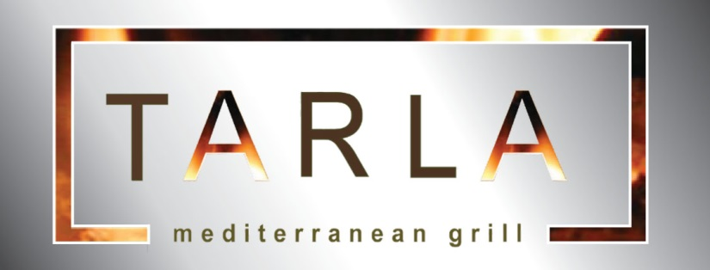

Dinner Prix Fixe Menu

Three Course Food + Show only $105 PP
Three Courses with Wine Pairing $130 PP

FIRST COURSE (choose one)

TURKISH BEEF MEATBALLS

Turkish Meatballs / White Truffle-Chickpea Pesto / English Peas / Yellow Potatoes / Kale

2013 Callia, Malbec | Argentina

GREEK SALAD ₲

Tomato / Onion / Cucumber / Olives / Bell Peppers / Feta / Lemon Dressing

2014 Ramon Bilbao, Albarino | Spain

SPANIKOPITA

Phyllo Dough Stuffed with Spinach and Feta

2014 Balletto, Pinot Gris | Russian River Valley

SAGANAKI**

Cyprus Island Flaming Halloumi Cheese / Truffle Honey / Apricots / Toast

Twenty Four by C. Woodson | Napa Valley

SECOND COURSE (choose one)

GRILLED CHICKEN SHISH KEBAB**

Roasted Baby Carrots / Beets / Fingerling Potatoes / Garlic Confit/ Okra and Chimichurri

2012 Trinitas Chardonnay | Carneros | Napa Valley

POMEGRANATE-CABERNET BRAISED SHORT RIBS ₲

Roasted Mushroom-Truffle Risotto / Beef Au Jus / Pickled Spicy Cherry Peppers

2013 Filus, Reserve Malbec | Mendoza | Argentina

PAN ROASTED BRANZINO**

Roasted Branzino / Saffron Couscous / Sautéed Brussel Sprouts /

Lemon Caper Beurre Blanc

2013 Chardonnay Charles Krug | Carneros | Napa Valley

WHITE TRUFFLE MUSHROOM RISOTTO ₲

California Arborio Rice / Crispy Kale Chips / Wild Mushrooms / Parmesan Cheese

2014 Adastra Chardonnay | Napa Valley

THIRD COURSE (choose one)

TRADATIONAL WALNUT BAKLAVA
With Vanilla Gelato

2010 | Trinitas Moscato | California
STUFFED TURKISH APRICOTS
With Chardonnay Apricot Sorbet.

Anne De Codorniu, Brut Cava | Spain

BOURBON CHOCOLATE BREAD PUDDING

Vanilla Bean Gelato

Trahan Port | Napa Valley 2012

Please Inform Your Server of Any Special Dietary Restrictions You May Have

₲ Gluten Free | ** Gluten Free Modifiable

Chef De Cuisine Marcos Ahumada

